DLL PROJECT OUTPUTS
Safak Ruya Yurek

1.Menu:
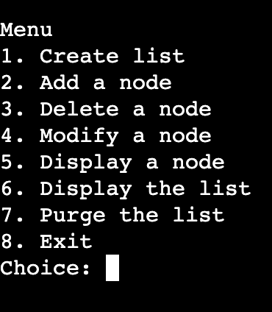

2. Actions when list is not created
addNode:

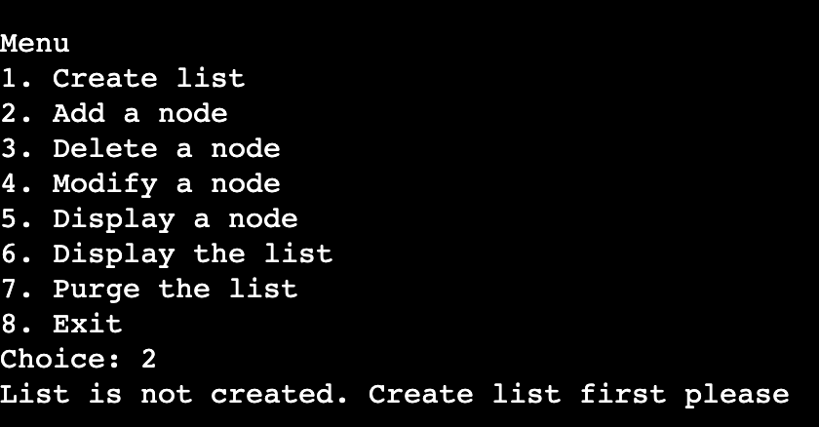

delNode:
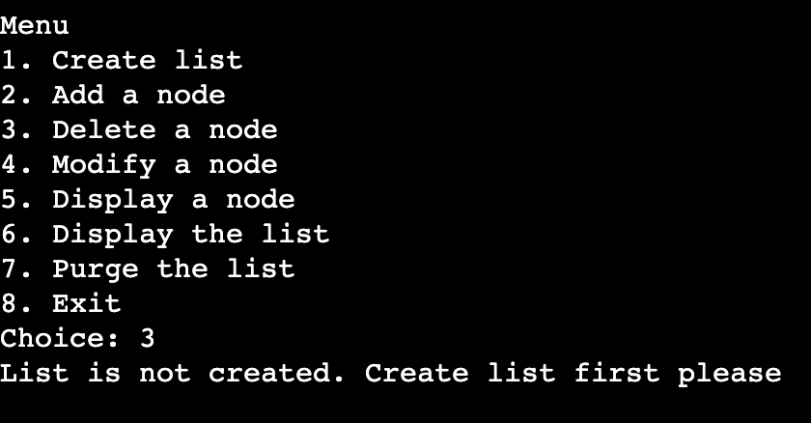

modifyNode:
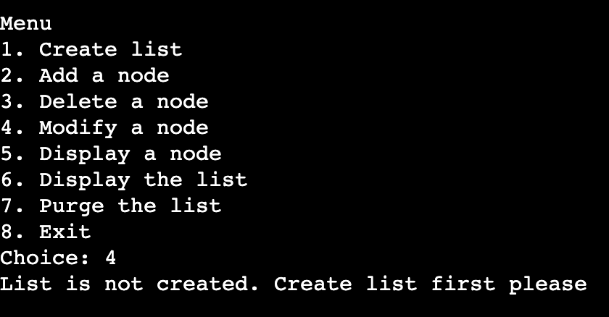

displayNode
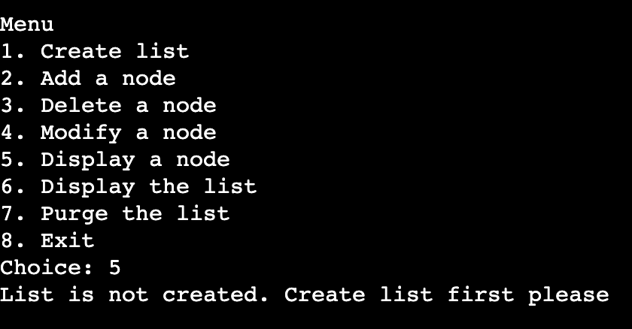

displayList
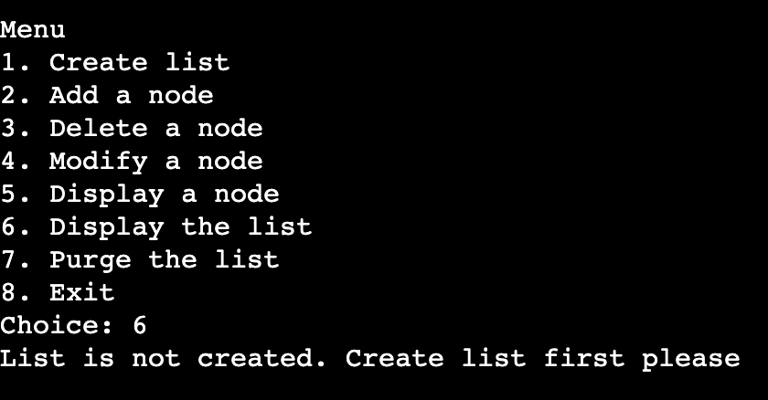

purgeList:
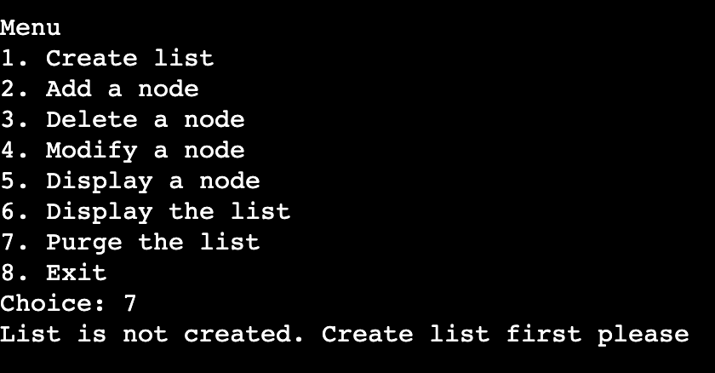

3.Create list (checklist1)
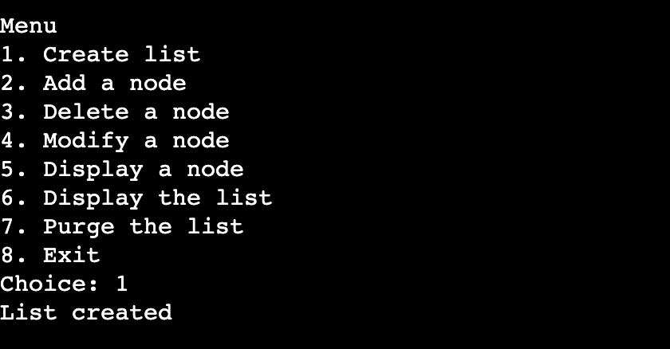

4. When list is created, but is empty, no actions should be
executed except adding a node/purge

delNode:

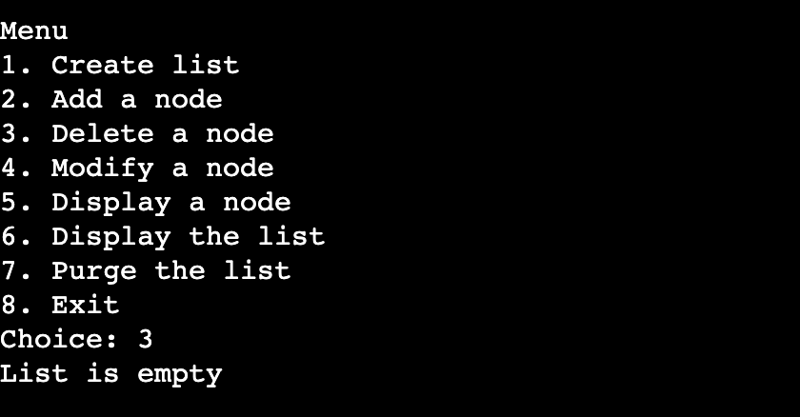
modifyNode:
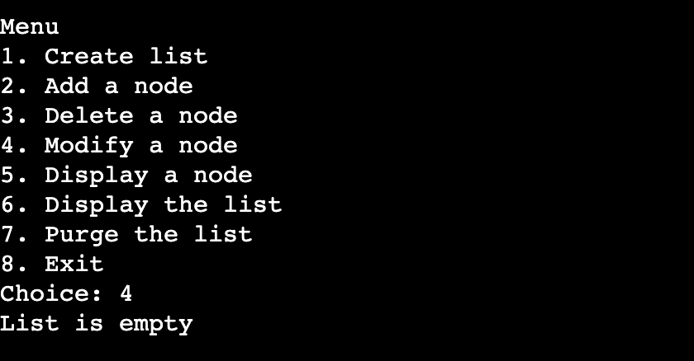

displayNode
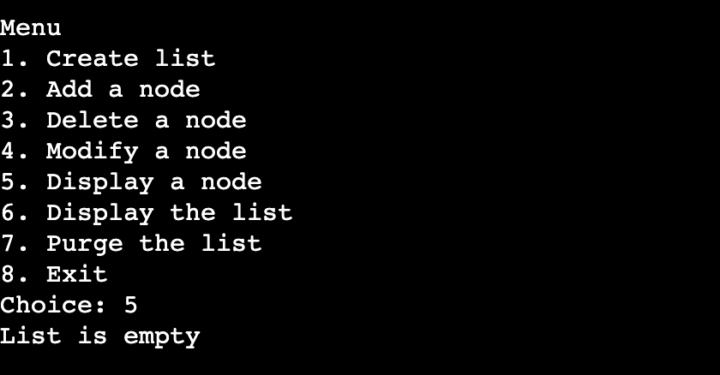

displayList
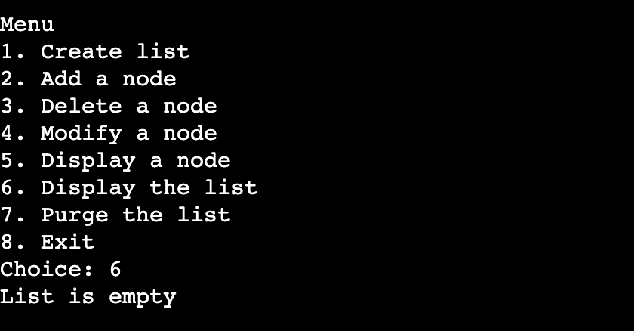

5. Adding node in an empty list, then displaying node (Checklist 2)
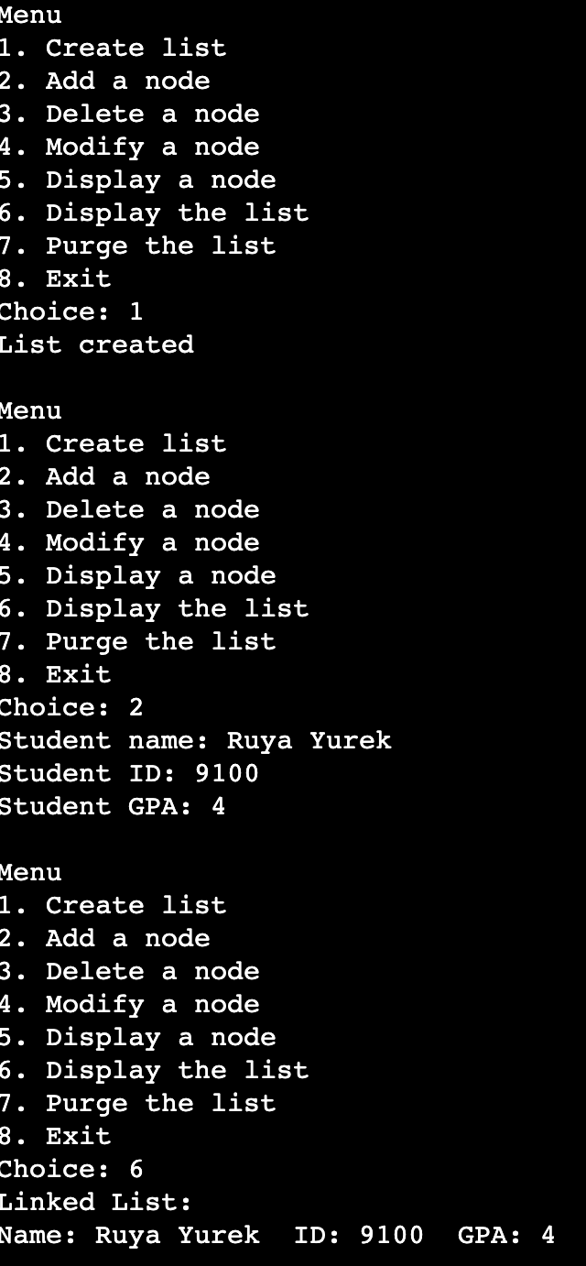

6. Adding a node to the front of the list: (Checklist 3)
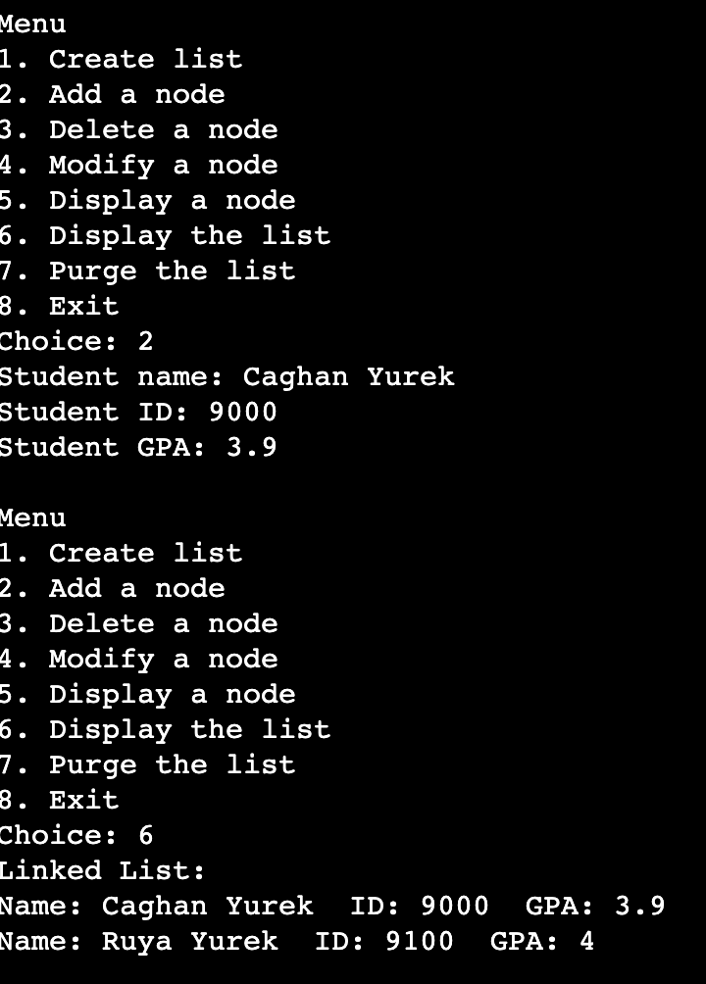

7. Adding node to the end of the list: (Checklist 4)
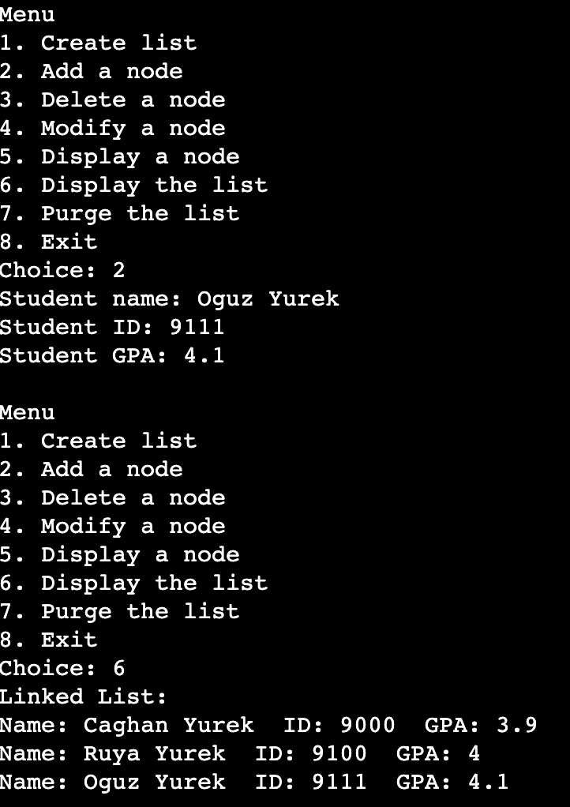

8. Adding node in the middle of the list: (Checklist 6)

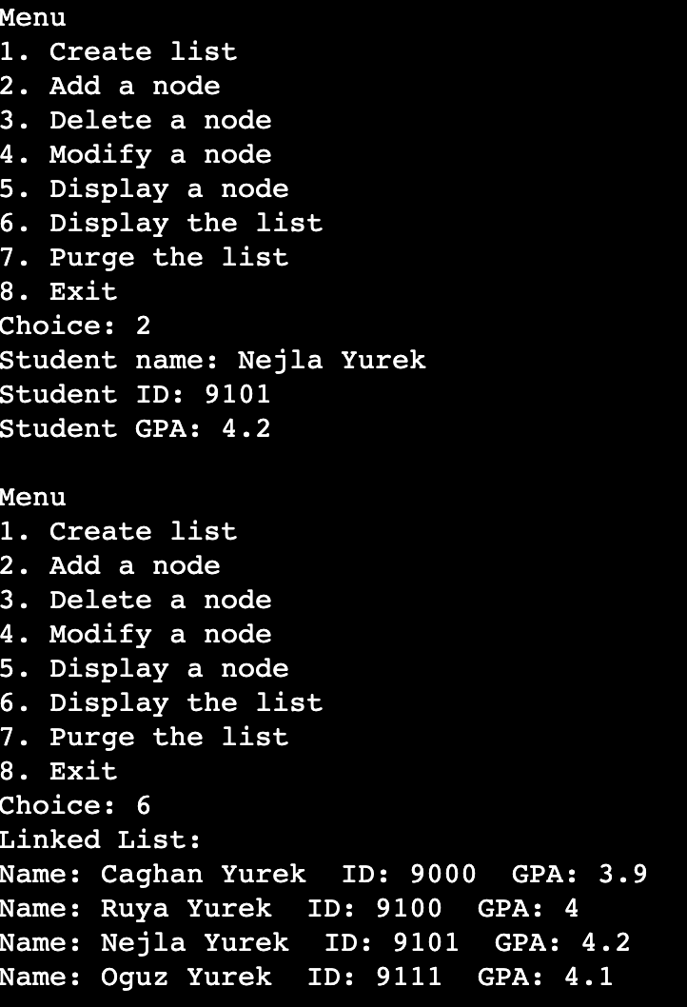

9. Attempting to add node with existing ID (Checklist 5)
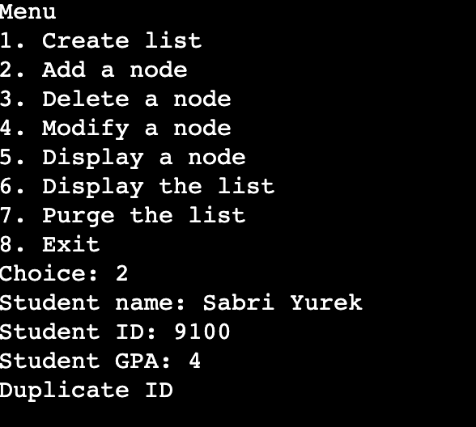

10. Deleting Nodes:
Deleting Node when list is empty: (Checklist 7)

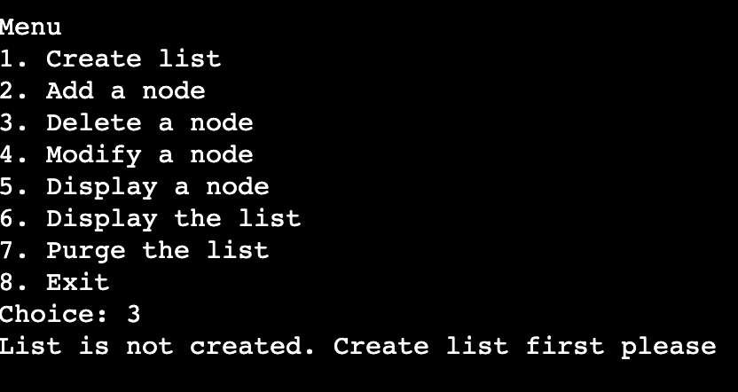

Deleting node from front: (Checklist 8)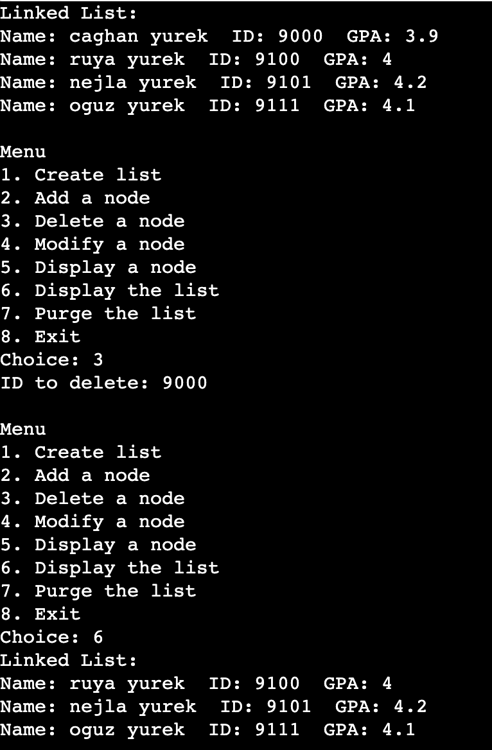

Deleting node from middle: (Checklist 10)

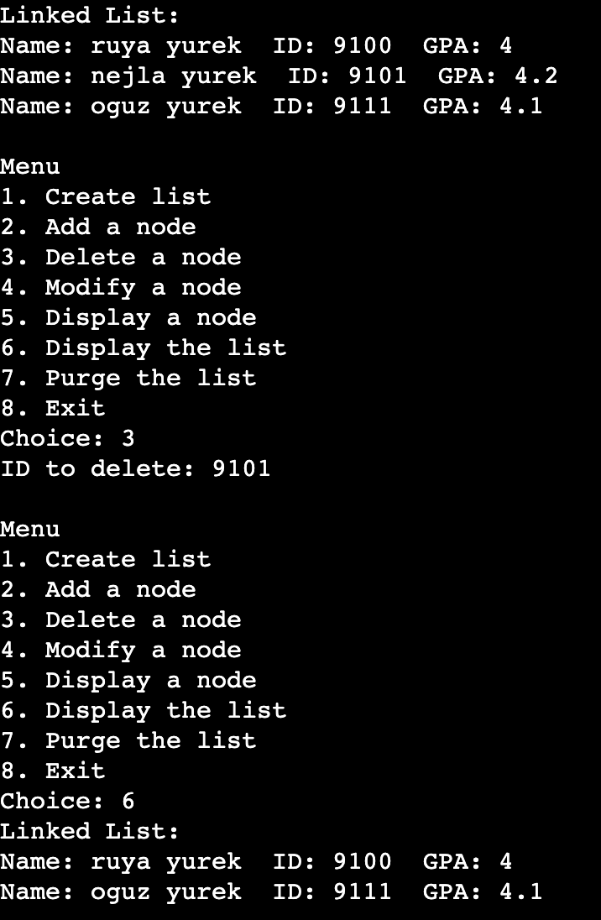

Deleting node from end: (Checklist 9)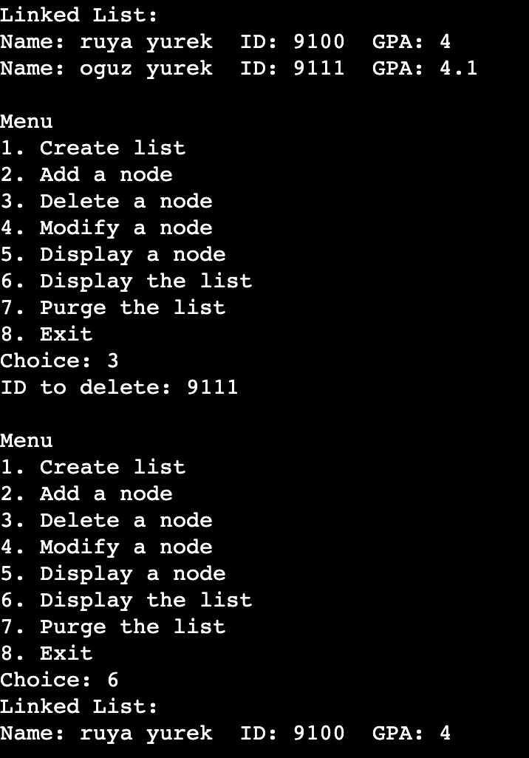

Deleting non-existent node:

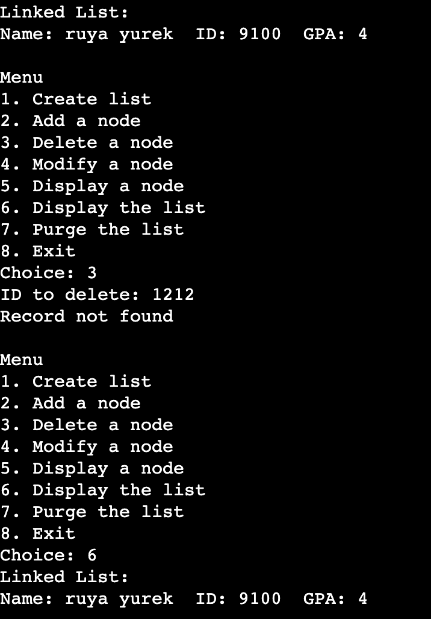

11. Searching/Displaying nodes
Displaying node that exists in list: (Checklist 11)
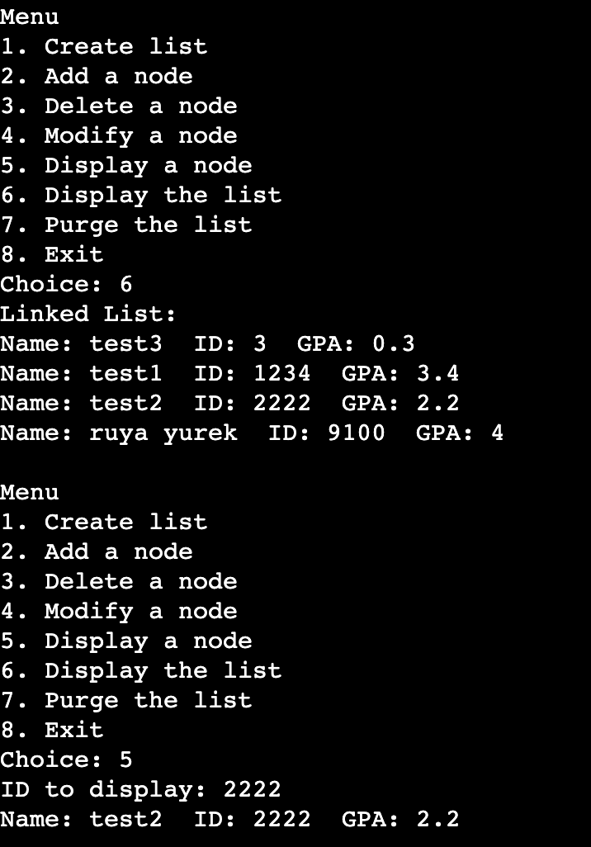

Displaying node that doesn’t exist in list: (Checklist 12
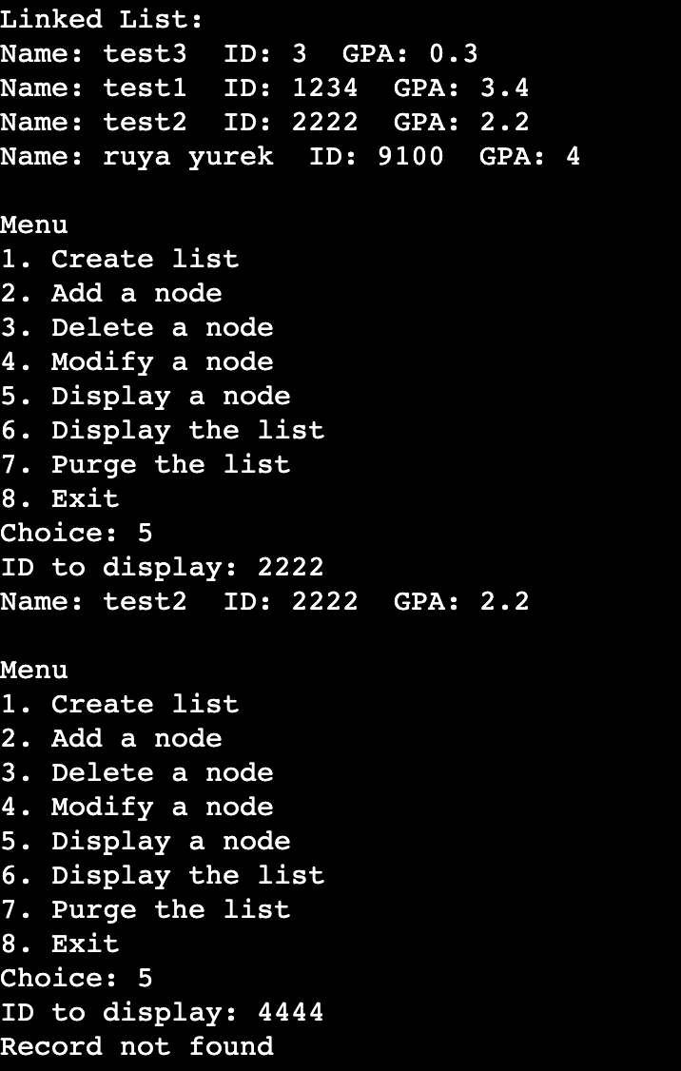

12. Modifying nodes:
Modifying node that exists: (Checklist 13)

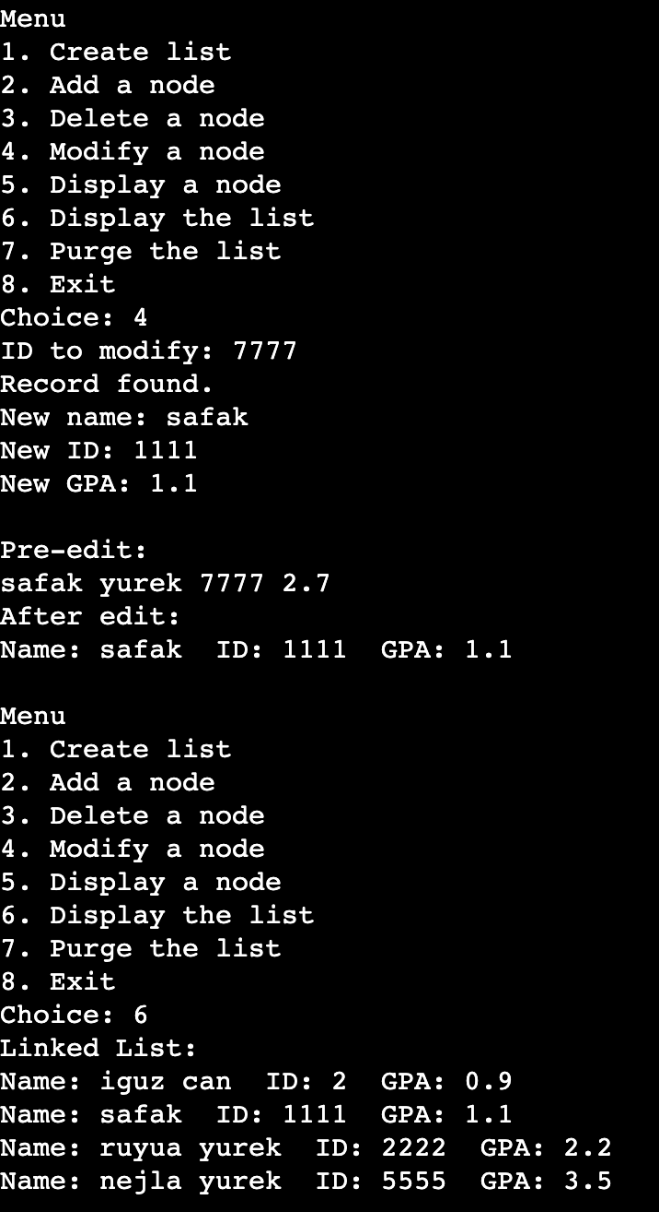

Modifying node that doesn’t exist:
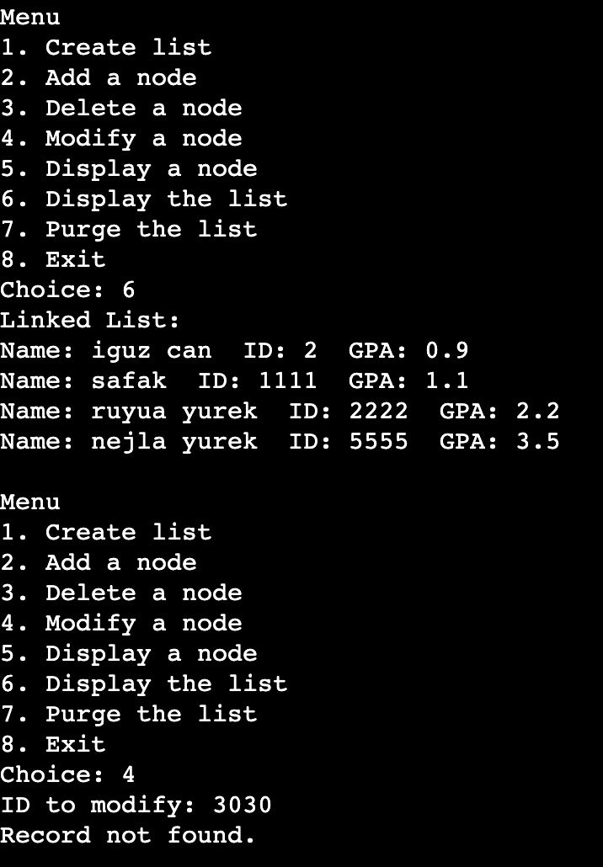

13. Purging entire list: (Checklist 14)
